- Develop a python program to perform binary classification and evaluate performances using Confusion matrix, ROC Curve, Precision, Recall and F1 Score for any given data-set.
Dataset: heart disease
Code:
# importing Required libraries
import pandas as pd
import numpy as np
import matplotlib.pyplot as plt
import seaborn as sns
from sklearn.model_selection import train_test_split
from sklearn.linear_model import LogisticRegression
from sklearn.metrics import (
confusion_matrix, classification_report,
roc_curve, roc_auc_score, precision_score,
recall_score, f1_score
)

#Loading the datset
df = pd.read_csv('heart.csv')
#Basic information of the dataset
df.head(10)
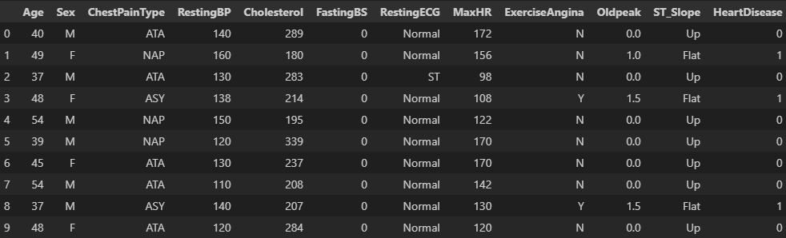
df.shape

df.dtypes
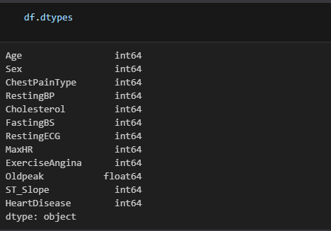
df.describe()
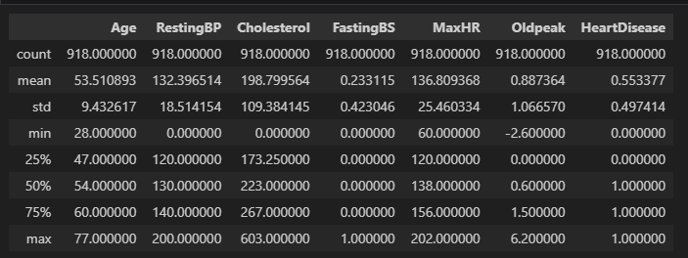
df.isnull().sum()
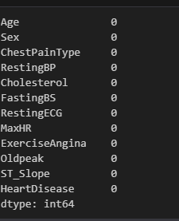
print("\nMissing values:\n", df.isnull().sum())

2. Exploratory Data Analysis (EDA)
sns.countplot(data=df, x="HeartDisease")
plt.title("Heart Disease Distribution")
plt.show()
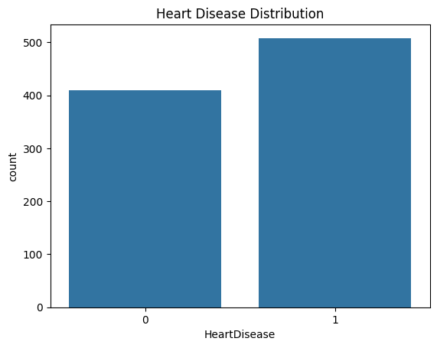
# Pairplot for a few features vs HeartDisease
sns.pairplot(df, hue='HeartDisease', vars=['Age', 'RestingBP', 'Cholesterol', 'MaxHR', 'Oldpeak'])
plt.show()
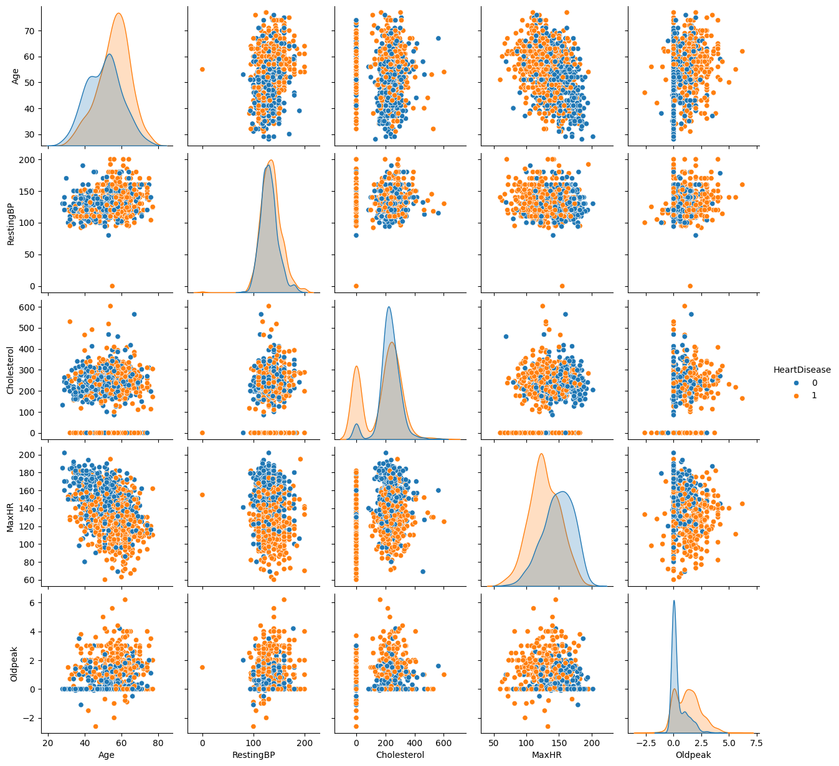
# Features(x) and target(y)
X = df.drop("HeartDisease", axis=1)
y = df["HeartDisease"]

# Train-test splitting
X_train, X_test, y_train, y_test = train_test_split(X, y, test_size=0.2, random_state=42)

#Model Building (Logistic Regression)
# Initializing and train model
model = LogisticRegression (max_iter=1000)
model.fit(X_train, y_train)

# Predicting on test set
y_pred = model.predict(X_test)
y_prob = model.predict_proba(X_test)[:, 1]

#Model Evaluation
A. Confusion Matrix and Classification Report
# Confusion Matrix
cm = confusion_matrix(y_test, y_pred)
sns.heatmap(cm, annot=True, fmt="d", cmap="Blues")
plt.xlabel("Predicted")
plt.ylabel("Actual")
plt.title("Confusion Matrix")
plt.show()
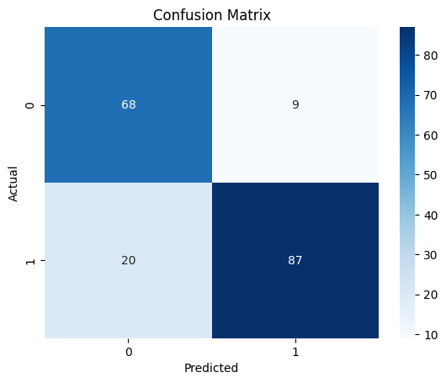

# Classification Report
print("\nClassification Report:\n")
print(classification_report(y_test, y_pred))
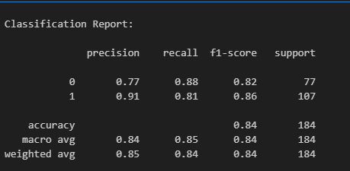
B. ROC Curve
# ROC Curve
fpr, tpr, _ = roc_curve(y_test, y_prob)
roc_auc = roc_auc_score(y_test, y_prob)
plt.plot(fpr, tpr, color='darkorange', lw=2, label='ROC curve (AUC = %0.2f)' % roc_auc)
plt.plot([0, 1], [0, 1], color='navy', linestyle='--')
plt.xlabel("False Positive Rate")
plt.ylabel("True Positive Rate")
plt.title("Receiver Operating Characteristic (ROC)")
plt.legend(loc="lower right")
plt.show()
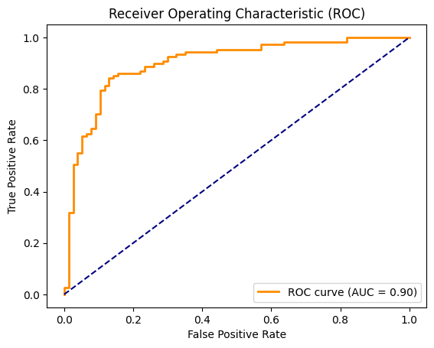

C. Precision, Recall, F1 Score
print("Precision Score:", precision_score(y_test, y_pred))
print("Recall Score:", recall_score(y_test, y_pred))
print("F1 Score:", f1_score(y_test, y_pred))
